Lab 7.5.1: Basic Wireless Configuration

Topology Diagram

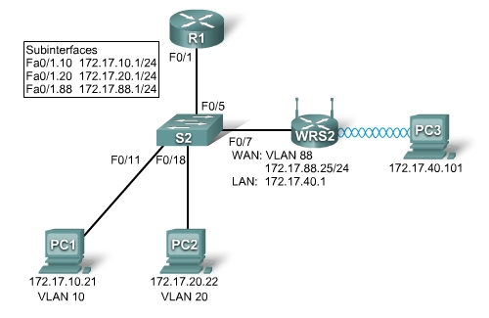

Learning Objectives
- Configure options in the Linksys Setup tab.
- Configure options in the Linksys Wireless tab.
- Configure options in the Linksys Administration tab.
- Configure options in the Linksys Security tab.
- Add wireless connectivity to a PC.
- Test connectivity.

Introduction
In this activity, you will configure a Linksys wireless router, allowing for remote access from PCs as well as wireless connectivity with WEP security.
Task 1: Load the starting configurations.
Step 1. Load R1’s configurations.

hostname R1
!
interface FastEthernet0/0
ip address 172.17.50.1 255.255.255.0
no shutdown
!
interface FastEthernet0/1
no ip address
no shutdown
!
interface FastEthernet0/1.10
encapsulation dot1Q 10
ip address 172.17.10.1 255.255.255.0
!
interface FastEthernet0/1.20
encapsulation dot1Q 20
ip address 172.17.20.1 255.255.255.0
!
interface FastEthernet0/1.88
encapsulation dot1Q 88
ip address 172.17.88.1 255.255.255.0
!

Step 2. Load S2’s configurations.

hostname S2
!
interface FastEthernet0/5
switchport mode trunk
no shutdown
!
interface FastEthernet0/7
switchport access vlan 88
switchport mode access
no shutdown
!
interface FastEthernet0/11
switchport access vlan 10
switchport mode access
no shutdown
!
interface FastEthernet0/18
switchport access vlan 20
switchport mode access
no shutdown
!
Task 2: Connect and log into the Wireless Router.
To clear any previous configurations, do a hard reset. Find the reset button on the back of the router. Using a pen or other thin instrument, hold down the reset button for 5 seconds. The router should now be restored to its factory default settings.
The WEB GUI will be used to configure the settings on the wireless router. The GUI can be accessed by navigating to the router’s LAN/Wireless IP address with a web browser. The factory default address is 192.168.1.1.
Step 1. Establish physically connectivity.
Connect a straight through cable from the PC to one of the wireless router’s LAN ports, labeled Ethernet 1 - 4. By default, the wireless router will provide an IP address to the PC using default DHCP configurations.
Step 2. Open a web browser.
Step 3. Navigate to the wireless router’s Web Utility.
- Set the URL of the browser to http://192.168.1.1.
The default login credentials are a blank username and a password of: admin. Note that this is very insecure since it is the factory default and provided publicly. We will set our own unique password in a later task.
Step 4. Log in
- Leave the username blank and set the password to: admin.
Task 3: Configure Options in the Linksys Setup Tab.
Step 1. Set the Internet connection type to static IP.
- By default the start up page is the Setup screen. In the menus at the top notice you are in the Setup section and under the Basic Setup tab.
- In the Setup screen for the Linksys router, locate the Internet Connection Type option in the Internet Setup section of this page. Click the drop-down menu and select Static IP from the list.
Step 2. Configure the VLAN 88 IP address, subnet mask, and default gateway for WRS2.
- Set the Internet IP address to 172.17.88.25.
- Set the Subnet Mask to 255.255.255.0.
- Set the Default Gateway to 172.17.88.1.
Note: Typically in a home or small business network, this Internet IP address is assigned by the ISP through DHCP or PPPoE. (The specifics of PPPoE are outside the scope of this course.)
Step 3. Configure the router IP parameters.
- Still on the Basic Setup page, scroll down to Network Setup. For the Router IP fields do the following:
    - Set the IP address to 172.17.40.1 and the subnet mask to 255.255.255.0.
    - Under the DHCP Server Setting, ensure that the DHCP server is Enabled.
Step 4. Save settings.
Click the Save Settings button at the bottom of the Setup screen.
Note that the IP address range for the DHCP pool adjusts to a range of addresses to match the Router IP parameters. These addresses are used for wireless clients and clients that connect to the router’s internal switch. Clients receive an IP address and mask, and are given the router IP to use as a gateway.

Step 5. Reconnect to WRS2.
Since we have changed the router’s IP address and DHCP pool, we will have to reconnect to it using the new address previously configured.
- Reconnect to the router. You will need to reacquire an IP address from the router via DHCP or manually set your own.
- Reconnect to the router’s configuration GUI using an IP address of 172.17.40.1. Remember to use the default password of admin.
Task 4: Configure Options in the Linksys Wireless Tab.
Step 1. Set the network name (SSID).
- Click the Wireless tab.
- Under Network Name (SSID), rename the network from linksys to WRS_LAN_number, where number is a unique ID assigned by your instructor corresponding to your group number. This will help to avoid conflicts with other students working on this lab at the same time.
- Click Save Settings.
Step 2. Set the security mode.
- Click Wireless Security. It is located next to Basic Wireless Settings in the main Wireless tab.
- Change Security Mode from Disabled to WEP.
- Using the default Encryption of 40/64-Bit, set Key1 to 1234567890,
- Click Save Settings.
Task 5: Configure Options in the Linksys Administration Tab
Step 1. Set the router password.
- Click the Administration tab.
- Under Management in the Router Access section, change the router password to cisco123. Re-enter the same password to confirm.
Step 2. Enable remote management.
- In the Remote Access section, set Remote Management to Enabled.
- Click Save Settings.
- You may be prompted to log in again. Use the new password of cisco123 and still keep the username blank
Task 6: Configure Options in the Linksys Security Tab
By default ping requests to WRS2’s LAN/Wireless interface (172.17.40.1) from sources on its WAN interface (for example PC1 & PC2) will be blocked for security reasons implemented by the wireless router. For the purpose of verifying connectivity in this lab we would like to allow these pings.
Step 1. Allow anonymous internet requests.
- Click the Security tab.
- Under Internet Filter, uncheck Filter Anonymous Internet Requests.
- Click Save Settings.
Task 7: Add Wireless Connectivity to a PC
Step 1. Disconnect the Ethernet connection from PC3 to WRS2.
Step 2: Use Windows XP to connect to the wireless router.
The following steps in this task demonstrate how to use Windows XP's built in Wireless Network Connection Utility. Depending on the model of NIC you use, this might be disabled, and you will need to use the utility provided by the NIC manufacturer. Consult your instructor for instructions if this is the case.
- Locate the Wireless Network Connection icon in your taskbar, or go to Start > Control Panel > Network Connections.
- Select the Wireless Network Connection.
- Navigate to the File menu and select Status.
- Click View Wireless Networks.
- Locate the ‘WRS_LAN_number’ SSID in the list of available networks and connect to it.
- When prompted for the WEP key enter it as in Task 3, 1234567890 and click Connect.
Step 3: Verify the Connection.
- In the Status window, select the Support tab. Verify that PC3 has received an IP address from WRS2’s DHCP address pool or has been manually configured.
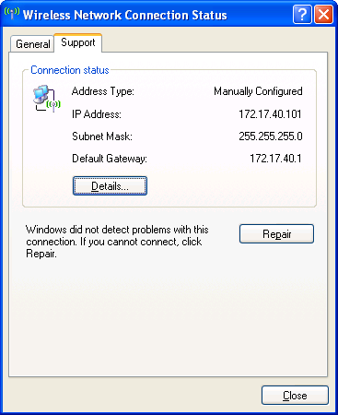
Task 8: Test Connectivity
Step 1. Ping WRS2’s LAN/Wireless interface.
- On PC3, click Start->Run
- Type cmd and select open. This will open the command prompt
- In the command prompt type (without quotes) “ping 172.17.40.1”.
Step 2. Ping R1’s Fa0/1.88 Interface.
- In the command prompt type (without quotes) “ping 172.17.88.1”
Step 3. Ping PC1 and PC2 from PC3.
- In the command prompt type (without quotes) “ping 172.17.10.21” to ping PC1.
- Repeat on PC2’s address, 172.17.20.22.
Note: Due to the security on the WRS, PC 3 can ping both PC 1 and 2, but PC 1 and 2 are not able to ping PC 3.
Task 9: Erase Configuration
Erase the configuration on the WRS by navigating to the Administration page, selecting the Factory Defaults tab, and clicking the Restore All Settings button.

